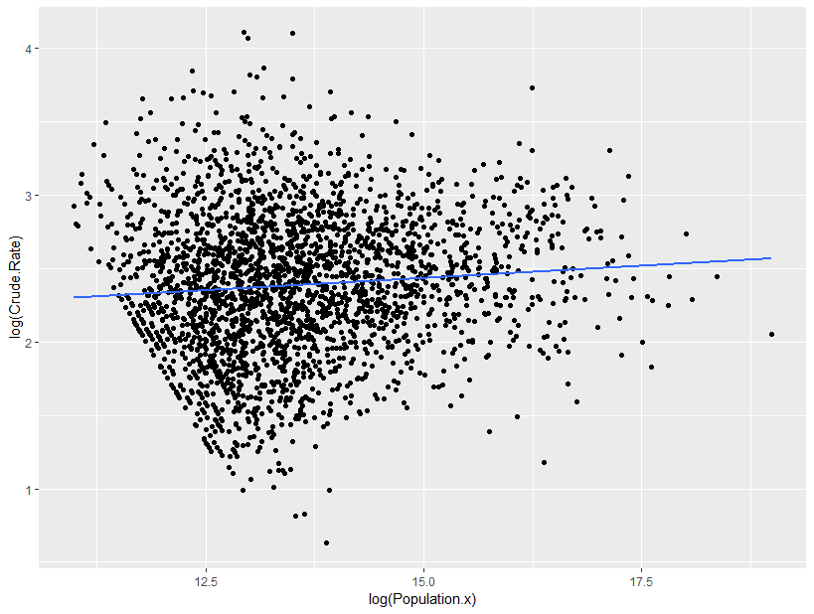

Weird downward lines at the left - missing data??

Call:

lm(formula = log(Crude.Rate) ~ log(Population.x))

Residuals:

Min 1Q Median 3Q Max

-1.76712 -0.30746 0.00362 0.31899 1.74132

Coefficients:

Estimate Std. Error t value Pr(>|t|)

(Intercept) 1.933708 0.104719 18.466 < 2e-16 \*\*\*

log(Population.x) 0.033386 0.007703 4.334 1.52e-05 \*\*\*

---

Signif. codes: 0 ‘\*\*\*’ 0.001 ‘\*\*’ 0.01 ‘\*’ 0.05 ‘.’ 0.1 ‘ ’ 1

Residual standard error: 0.4813 on 2598 degrees of freedom

Multiple R-squared: 0.007179, Adjusted R-squared: 0.006797

F-statistic: 18.79 on 1 and 2598 DF, p-value: 1.518e-05